**ADD User:**

**URL: POST –** <http://localhost:8081/user>

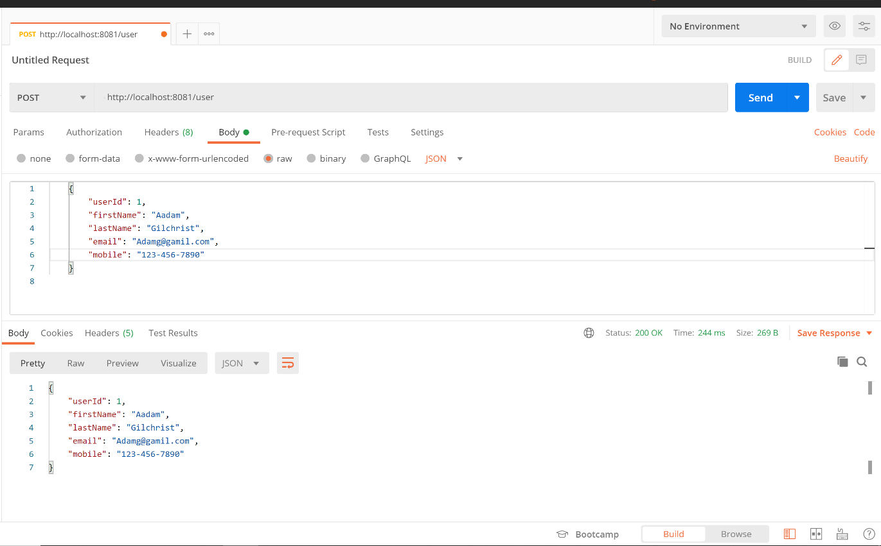

**Show all User:**

**URL: GET –** <http://localhost:8081/user>

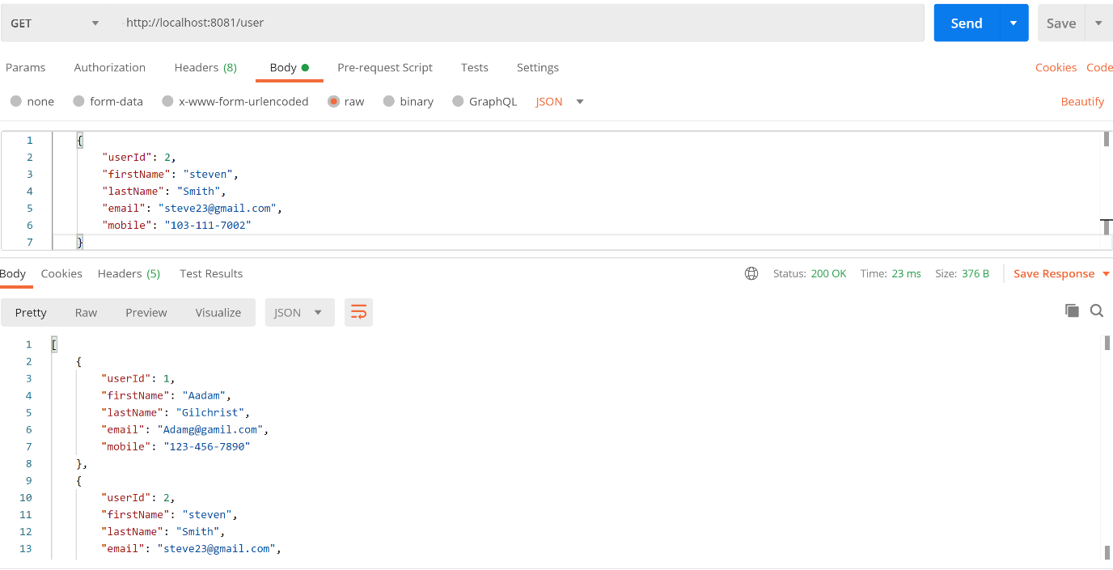

**DELETE User:**

**URL: DELETE** - <http://localhost:8081/user/>2

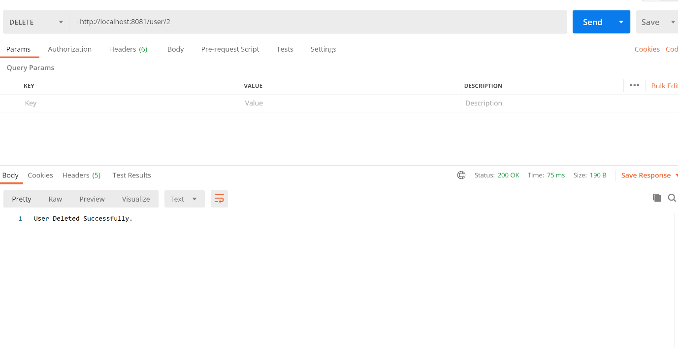

**ADD Interview:**

**url: POST-** <http://localhost:8081/interview>

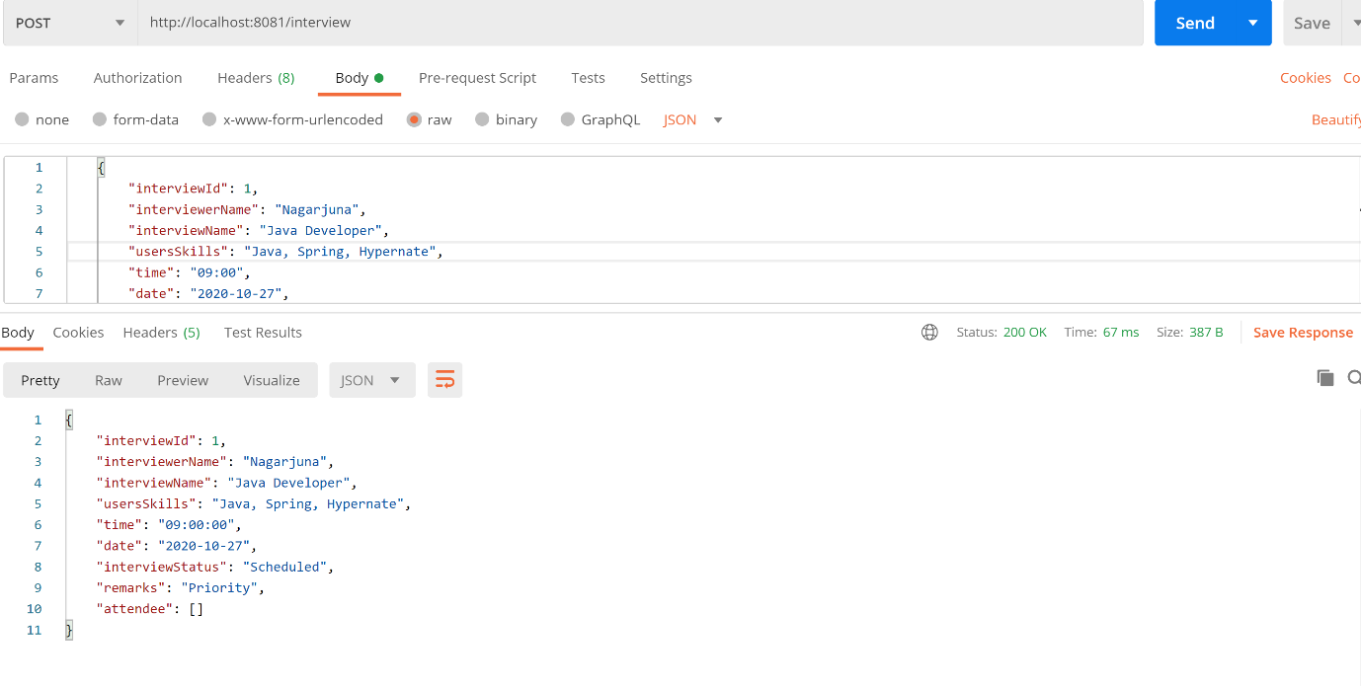

**Show All Interviews:**

**url: GET-** <http://localhost:8081/interview/showAllInterviews>

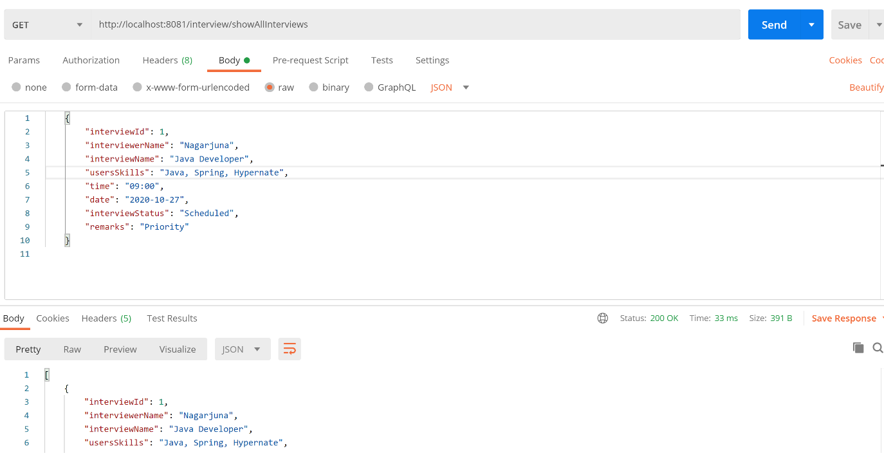

**Delete an Interview:**

**URL: DELETE-** <http://localhost:8081/interview/2>

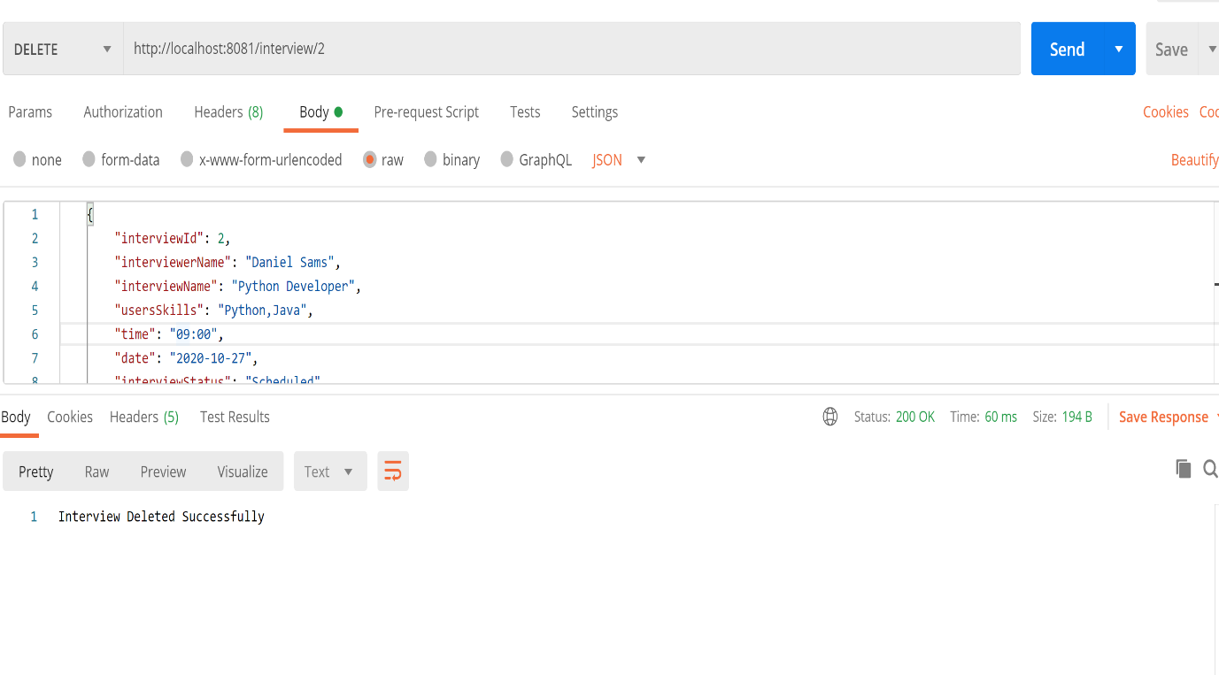

**Update interview Status:**

**url: PUT-** http://localhost:8081/interview/updateStatus/1/In Progress

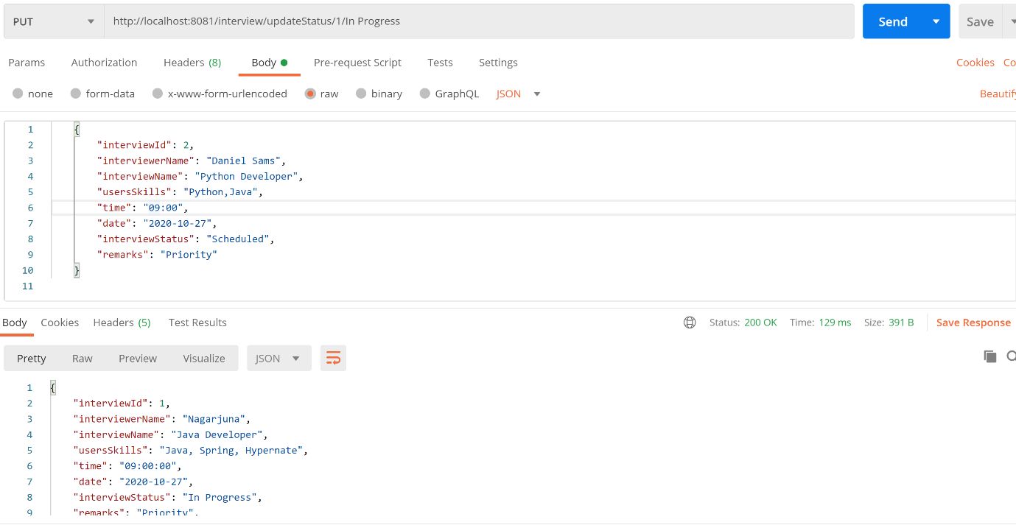

**Search for interview by interview name and interviewer name:**

**Url: GET-** http://localhost:8081/interview/showInterviewsByDeatils/Java Developer/Nagarjuna

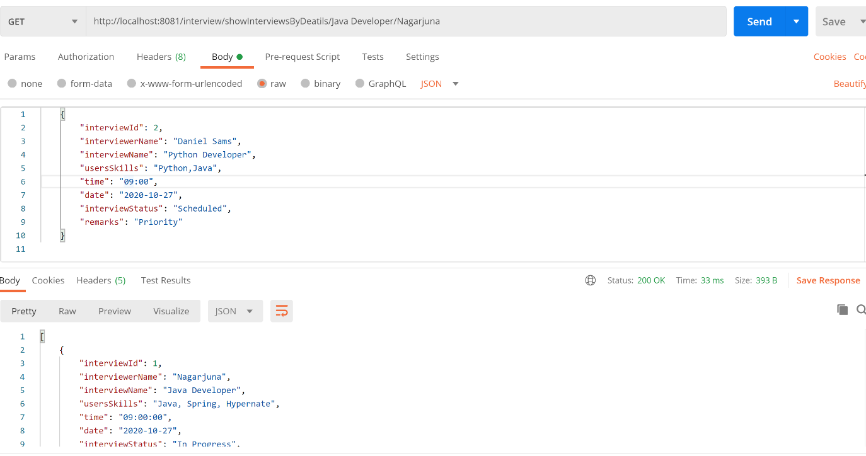

**GET Count of Interviews:**

**URL: GET-** <http://localhost:8081/interview/getCount>

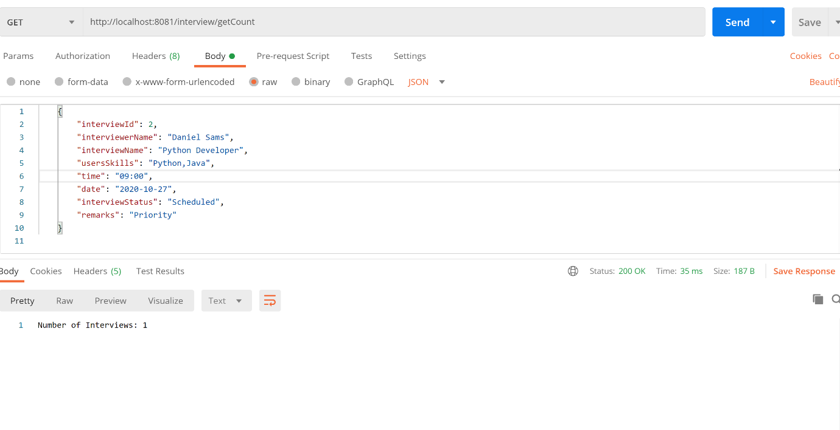

**ADD Attendee to Interview:**

**URL: PUT-** <http://localhost:8081/interview/addAttendee>

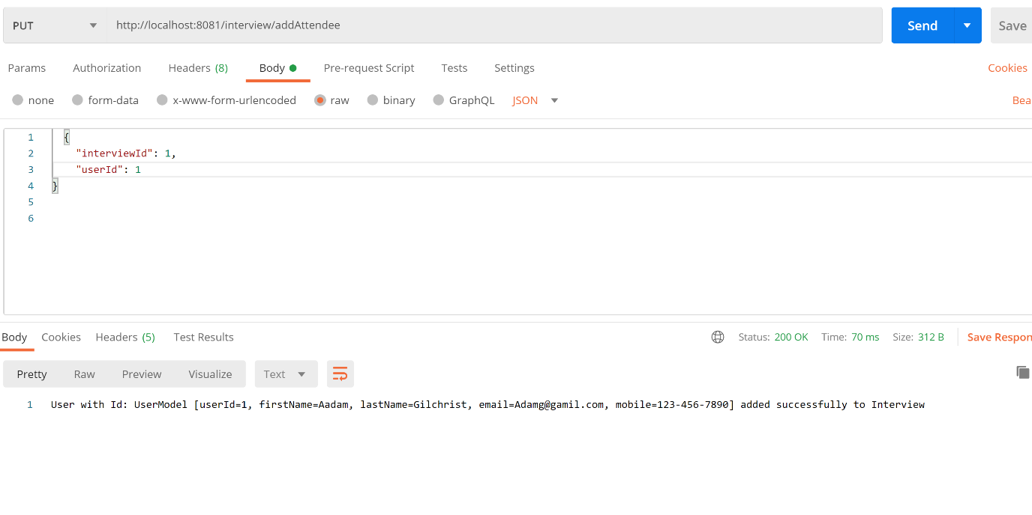

**Get all attendees by Interview ID:**

**URL: GET-** <http://localhost:8081/interview/showAttendee/1>

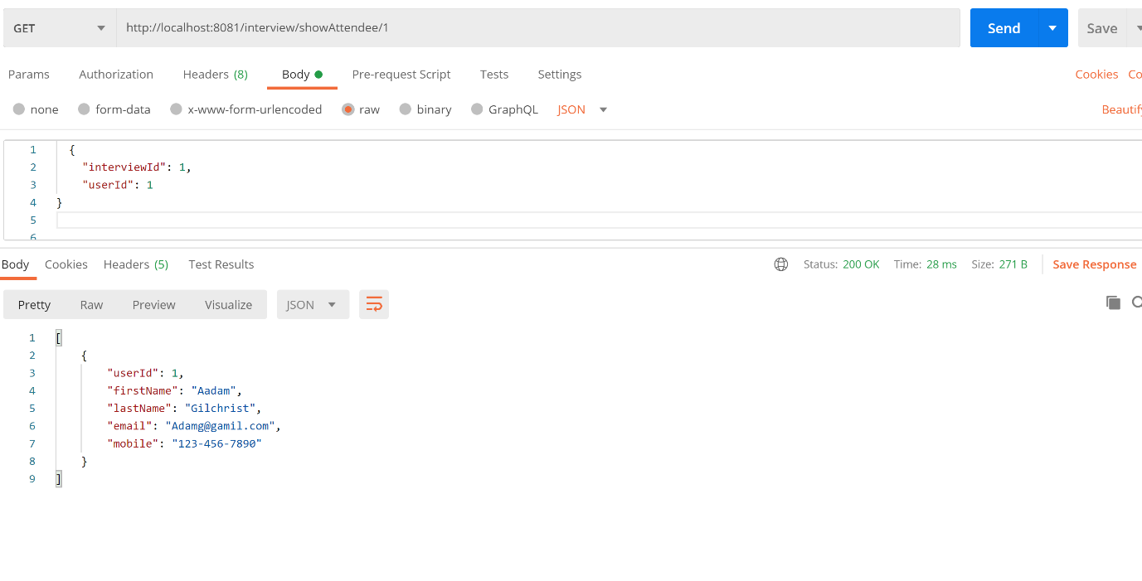

**Custom Error messages:**

**User model**

**Invalid username, mobile, Email**

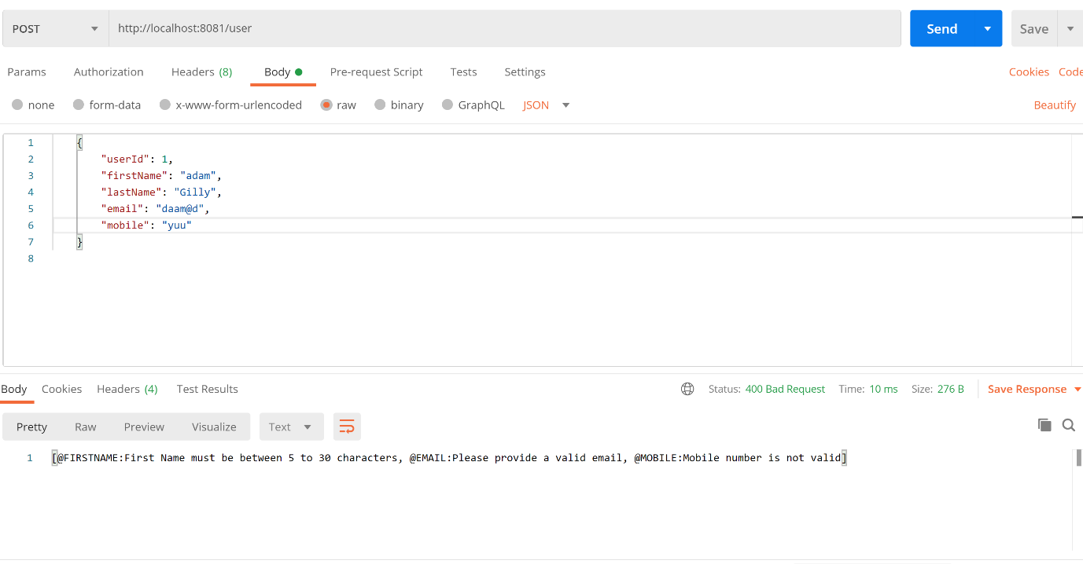

**Interview model field validations**

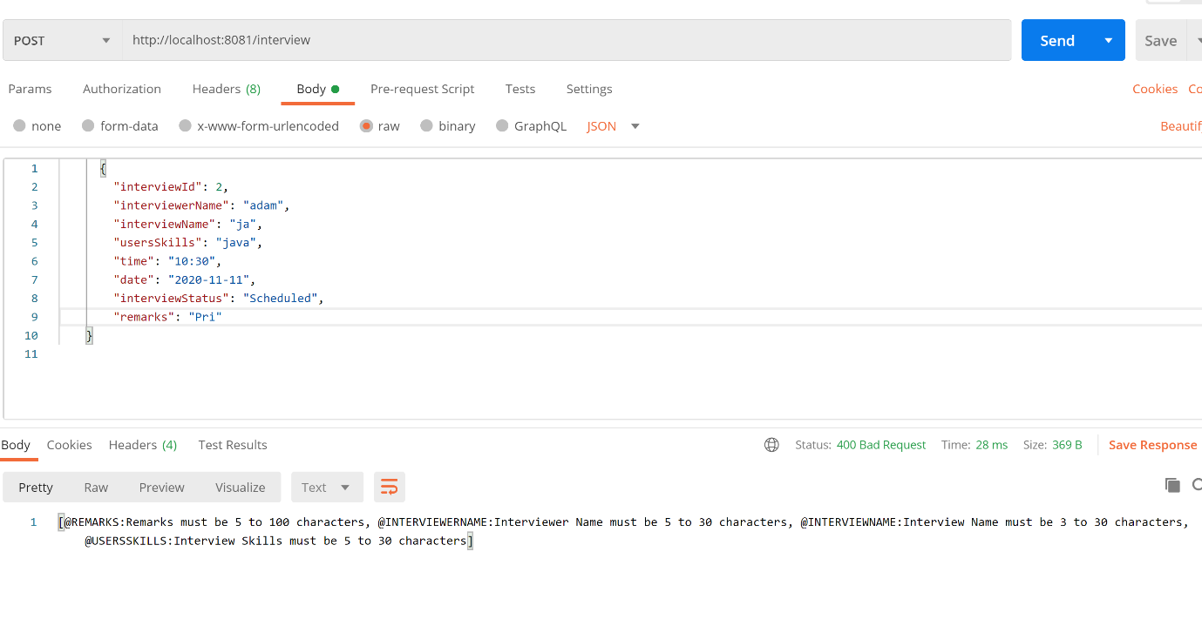

**Exception when duplicate interview id used**

